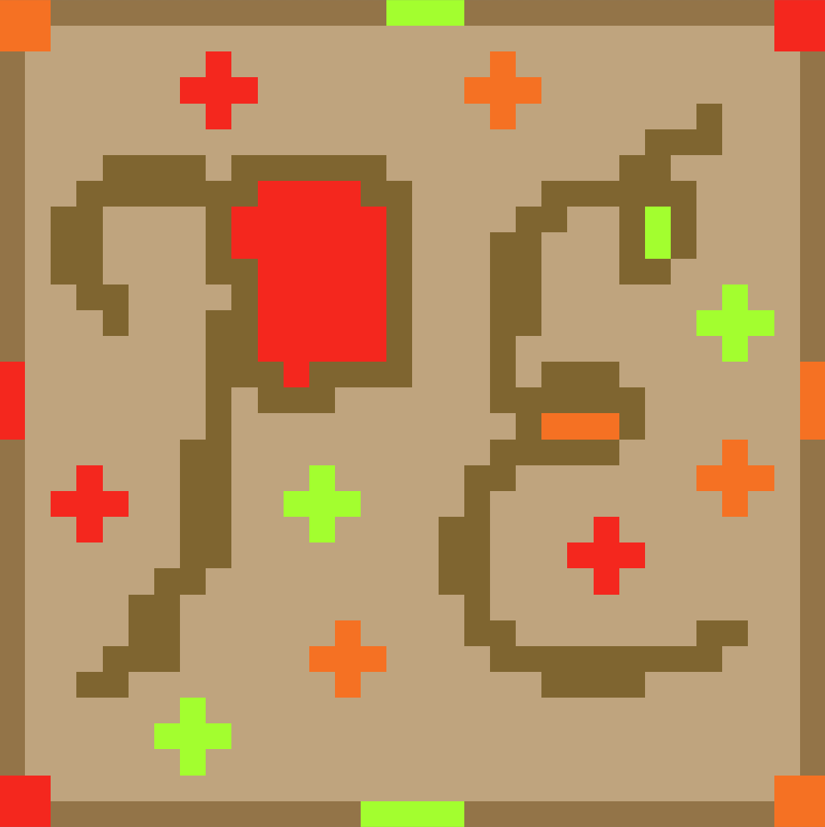
“Project: Egress”
Senior Capstone Project Final Report
Project Title | Project Egress
Team Members | Ethan Todd, Liam Bragg, Madeline Rosshirt
Link to Github | https://github.com/Fennec427/Project-Egress

Guidelines (erase this section when done):
- Suggested 10-15 pages, not including screenshots. Lower end for individual, higher end or more for group projects.
- 1.5 or double-spaced lines
- Can optionally replace MATES logo with your logo or an asset created for this project
- Don’t change the font types and sizes. Use black text.
- Erase blue section guidance once done with each section.

Executive Summary

Our project is called “Project Egress”. It is a 2-D puzzle platformer made in Unity with pixel art for graphics. Inspired by the video games Splatoon and Portal, the gameplay is centered around the use of different paint colors and their abilities across multiple levels of scaling difficulty. As you progress through the game, the three main paint colors you will encounter are red, orange, and green. Initially, the game starts at “Level 1” and is focused primarily on platforming and puzzles without any paint. Some of the first few challenges that the player will encounter in this level are stairs with buzzsaws in the corner of them, large gaps of spikes, small maneuvers around spikes, a demonstration of coyote time in the game (a feature that allows you to jump slightly farther past where a tile ends), a pitfall, and a large gap of spikes with a time based traps called “Fire Spitter(s)” that can make each trial through a section different and more difficult or less difficult than the previous attempt. Next, you progress through to the next section that focuses on a completely new mechanic, the paint. The paint featured in this level is red and has a speed-based mechanic tied to it. In order to progress through the level, you must master the ability to cross large gaps and know the right moments to stop moving. Moving on the next level, “Level 3,” you are introduced to another one of the new paints (orange paint). Alongside red paint, you can use orange paint to bounce over large gaps, gain vertical height to cross sections, and speed through large open areas with ease. Finally, onto “Level 4” the player is tasked with moving through a more puzzle-centered platforming section with the most complex of our paint mechanics, the green paint. Green paint functions as a way to stick to surfaces and walk on them with essentially new gravity. This can allow you to climb up walls and even walk across ceilings. In order to beat the level, you must master the ability to move in the right direction and jump from wall to wall to cross over gaps and scale walls. Now, past the main parts of the game, a “Community Level” is also featured that is a stitched together level from a bunch of our friends that showcases how all of the paints can be used in many different ways based on different people’s interpretations of them. Overall, our game features interesting challenges (using buzzsaws, spikes, and time-based traps), unique mechanics (with our three paint painting mechanics), and fun progression allowing for you to get creative with solving levels in many different ways.

Detailed Summary

For our Senior Capstone project, we chose to make a video game. The initial intent for the project itself was to collaborate and create an interesting, well designed, unique game with fun features or mechanics. As a group, we decided to do a three person video game project specifically because not only did we have similar visions, but we also liked the idea of exploring game design, development and wanted an outlet to express that. We also figured that three (the maximum group size) would be the only sufficient way we could achieve or accomplish at least some of our goals when making our game. To start, the idea and conception of “Project: Egress” as a game really stemmed from our enjoyment of 2-dimensional platformers and the interesting mechanics of video games, such as the Portal series. The name really came out of the blue mainly because it stood out and because it expressed exactly the energy of what we wanted this game to be. We wanted to focus on a player character going through a facility (already showing some of our inspiration from Portal) trying to make it through by solving “puzzles” or rather areas designed for the player to actively think about the mechanic they are using in order to complete it.

Description: The final logo for “Project Egress” that we intentionally stylized to highlight the contrast between the dark, grey facility the game takes place in and the (what would have been) stylized character and mechanics surrounding them. Ethan made this logo. This logo, although fitting for our project, could probably be updated a little bit since it was made during the conception of our Senior Capstone project.
The puzzle aspect is where we got the “Egress” part of the name and the “Project” part just came from the facility aesthetic. The idea to use paints to grant the player unique abilities stemmed from the fact that not only was it a relatively simple mechanic (to play with specifically), but it also contrasted the aesthetics of the facility itself to make the player and the, mechanics surrounding the player, really stand out (although the ideas of using paint specifically more so stemmed from our collective knowledge of other video games and what we thought would work best with a 2-dimensional platformer.
The core of the game runs on Unity Engine 6.3 LTS (specifically, version 6000.3.10f1) (https://unity.com/releases/editor/whats-new/6000.3.10f1). This was the latest suggested version of Unity when the project was started. To make all the sprites, we used a website called “Piskel”, which lets users create pixel art (https://www.piskelapp.com). For coding, Unity requires code written in C#, so we used Visual Studio Code (around version 1.120) (https://code.visualstudio.com/) with the Unity and C# extensions found in the built-in extension store. For project collaboration and version control, our code is stored in a GitHub repository (https://github.com/Fennec427/Project-Egress). To make our task checklists, we used Trello (https://trello.com/b/D29yQgac/project-egress).
Some key milestones that were achieved included getting the player mechanics working, each level being finished, and the painting mechanic. The player mechanics include a custom gravity system, quality of life improvements such as coyote time and jump buffering, and respawning after death. Each level took time, so each one being finished is a milestone in itself. Painting is probably the biggest umbrella term here, as there are so many things included. First, each of the 3 paint effects need to be completed over everything else, as this is the point of painting. Then, the 3 pre-painted tiles would serve as an introduction to the paint’s effect, to allow the player to see what it does. Finally, the paint tool and the paintball projectiles would be created in order to let the player paint their own tiles.
Into the nitty-gritty of the game itself: Our initial plans were to try and make a game with roughly seven levels. Each level would not necessarily get progressively harder per say, they just would focus on a different aspect of the game. For example, “Level 1” was conceptualized as a level purely meant to showcase the game’s mechanics and platforming (without paint), “Level 2” would have been focused on a specific paint color and an additional tool, “Level 3” would have been the same, etc. The idea was essentially to allow the player to progressively get access to more and more tools over the course of each level in order to get through sections in each level. On top of that, we planned on having alternate “paint tools” to allow the player to also consider how they wanted to experiment each level.
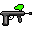
Description: An image of the final design for the one, and only, tool that made the cut, the “Paint Gun.” Functionally, it circles around the player character and follows the player’s mouse and is able to be shot all around to shoot physics-based paintball projectiles that color normal tile surfaces. An additional wheel can be used to switch paints, on some occasions, throughout levels. The color in the sprite changes depending on what paint is being used! An image of a paint ball is also included here!
The specifics of how we wanted to go through this level based progression weren’t entirely thought through when we conceptualized the project, which may have been our first fault. On top of that, we didn’t really have any huge ideas on specifically how we wanted to challenge the player. For example, throughout the creation of our project, we kind of spontaneously came up with trap ideas that would be both feasible to create in the time we had but also provided us with a way of making interesting levels. This is something that should have come up beforehand as it definitely halted progress a little bit since we didn’t have too much direction in that part. To entirely summarize the reason why we made the project and how we conceptualized it, I would say that we mainly focused on the creative, unique, and fun aspects of our game without really considering the specifics of not only how we specifically wanted to achieve this, but also on the less interesting, but still important, ways of achieving those things we decided to really hone in on.
In terms of the method of dividing the work we wanted to do, it wasn’t too difficult for us to really figure out. For starters, we figured out what each of us were best at. Liam was definitely the best at coding because he has had even more experience with coding outside of the two coding courses we had taken prior. He really wanted to take up a lot of the coding in this project, especially the really difficult stuff, and so we agreed on this. Ethan was primarily interested in a lot of the creative aspects of the project. In terms of what we decided on, we figured that it would be best for him to take on the role of designing the levels and doing some coding primarily with doing some of the creative work with sprites and stuff on the side (since Liam didn’t particularly find any interest in exploring this topic). For Madeline, she mainly also liked a lot of the creative aspects of the project too, but didn’t really want to go too far in depth with level creation. In the end, she kind of focused on conceptualizing a lot of the ideas for the project on top of coding as well, with again, a partial side task of making some sprites and exploring other creative aspects to our project, such as a story (which never ended up coming to full fruition). In the end, we mainly stuck to these roles, although we did kind of bounce around in different places throughout the project depending on what we needed to do when. For example, in the earlier stages of the project, level creation wasn’t really something that we could immediately start since we needed the foundations of our project up and running. So, the earlier parts of our project were mainly getting the game up and running, some of the prefabs functioning, and quickly designing some basic sprites to use (which we never ended up getting fully fleshed out like we had initially planned). Later on, however, level creation became a much bigger task to actually do and figure out so we all kind of shifted what we were doing around this specific type of scenario.
The actual scope of our project is a really big topic for discussion. To begin, our really big issue, as I mentioned earlier, was the fact that we didn’t really plan in the best ways possible, specifically with not accounting for how long things would take and only thinking about how fun and interesting they would be in terms of how they would function in our game itself. One of the first things we ended up having to trim was some of the traps we wanted to make. For example, as we started making the actual project and coming up with trap ideas, we started to realize the limitations of what we could feasibly have in our game. One trap which was initially conceptualized that never came to fruition was a “buzzsaw launcher” that would have essentially functioned as a tile that shot out moving, spinning buzzsaws (which did make it into the project) that would have ceased to exist the moment they came into contact with any other tile. This prefab also ended up getting as far as to have an entire sprite made for it (even though it was never actually used). The next thing that was conceptualized that never actually came to fruition was the “background tile” (although we definitely really wanted to include them). Similarly to the actual tiles (with collision) themselves, they would have looked similar and functioned similarly in terms of code. I am specifically referring to how the tiles themselves look and how they are randomized when actually placing them down and playing a level. The main difference between these tiles and the collidable tiles would have been that they would be more dim in color and also not be physically on the same layer as the player character. The reason why the background tiles never came to fruition also is tied to another thing we conceptualized but didn’t add. We never got to finish making a fully detailed sprite ourselves and instead kept our basic, but more intuitive, placeholder sprite. Essentially, because we didn’t have a fully colored sprite to contrast with the darker background tiles, we never got into making the background tiles. The big reason why we never got into making the fully detailed player character sprite is much more self explanatory. It was mainly due to time constraints and prioritizing more important aspects of our game (since the detailed player character sprite would have required full animations, like our placeholder has, and we wanted to at least have something that was actually animated over a still sprite that looked good). Both the detailed player character and the background tiles were at least fleshed out to the point where they had a basic sprite that existed (as in the detailed player character had a still model that was never added to our Unity Engine project and the background tile(s) was added into Unity Engine, although it only had one sprite).
In terms of things that never got added to our final project that didn’t really have any tangible progress made on them, there are some things that are important to note. Also, all of the following things I will mention never made the cut because of time constraints primarily (also connecting them to the things we didn’t get to in the paragraph prior to this). For starters, the main thing I would say that made the cut conceptually was the amount of and indirectly the types of levels we wanted to include in the game. Initially, we wanted seven total levels to allow the player to cleanly transition to different parts of the game and to overall guide the player through a more intuitive progression system. We essentially ended up trimming this down to four basic levels with three paints to have three levels with a focus on each individual paint and one level to focus on movement mechanics. On top of this, we also included a “Community Level” which allowed us to essentially make a “Level 5” that we didn’t get to, but wanted to to showcase all of the paints functioning in tandem with each other. Overall, we just ended up making a game with a much more narrow progression system. Because we never got to making more levels, what we had to cut also bled down a little bit more into specific things we wanted to include. To give a couple of examples, we wanted to possibly include more paint(s) to flesh out the seven level progression a little more and we wanted to include a level hub to showcase the seven levels themselves in an interesting way (since seven levels is kind of a lot to only have small buttons to progress between). Lastly, we never got to paint animations for our character because of our constraints with how we wanted to make the player character sprite and how we had to cut the detailed character sprite mid project and we never got to making a sandbox which would have allowed the player to understand how the game functioned better.
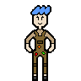
Description: A detailed, kind of unfinished, character sprite codenamed “Egress” that never got full animations and was, therefore, never included with the final project.
The sandbox was probably the biggest thing we wanted to include but had to cut due to time constraints. Still, a little bit of the sandbox was kind of included in the way we had the final level (the “Community Level” ) structured with all of its chaos.
If we ended up having much more time to work on the project, I would say that we definitely could have hit a lot more of the goals I mentioned in the previous section. If we just had another month to work on the project, I think we definitely could have made the full seven levels completely the way we wanted to, background tiles, and two other tools (like we had initially planned with our original three tool plan) too. I would say this is mainly because the bulk of the work was in the paint mechanic itself and since it is now up and running, I personally think that since our focus would mainly be on level creation and simpler ideas, like paint tools, we would have much more synergy and be able to create all of this in one month. I also believe that this is probably the path we would have taken given the project having to be done in June. Over time, if we had much more months to flesh out our game I would say the next important thing would be more traps to include in levels, a detailed character sprite with animations, painting animations for the character, a sandbox, and a level hub (in that order). All of this could probably be done in a total of two to three additional months (as a higher estimate).
In terms of what we actually did and how, Ethan mainly focused on the level creation and coding with a little bit of sprite work on the side.
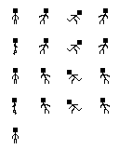
Description: A sprite sheet for the beginning placeholder character codenamed “John Egress.”
Personally, he had the biggest difficulty with learning how to do everything since, as he can testify, is not very good with computers and especially remembering things as such. Still, he made his best efforts and his results are documented here. To start, he had a lot of hiccups early on trying to get the virtual machine to actually work and also setting up the virtual machine itself. In the starting weeks, he and everyone all tried to divide up the work with the “Project Proposal,” “Project Pitch,” and “Project Scope” accordingly because they all were relatively straight forward assignments that could be easily divided up. He specifically made sure that he did his share of the work with setting up and writing down the information for the slides in the “Project Pitch,” editing the “Project Proposal,” and adding suggestions where he believed they were needed. Because he has a different block than Liam and Maddie, in terms of work, he could easily pass it on to Liam and Maddie, which should be a recurring theme here. Once all of the basic assignments were done, Ethan specifically got started with setting up and learning more stuff in relation to the project along with Maddie and Liam. Ethan specifically set up a notes document that helped contain information to help each other communicate between each other between blocks each day. On top of this, throughout the project, he consistently made sure the document was sorted, cleaned up, tracked nearly everything done, and was legible. Moving forward, setting up the virtual machines was the next big task. As Madeline and Ethan got to work reviewing articles, Liam, being done with most of that, already helped get the virtual machines set-up for everyone with instructions and such. For Ethan, it specifically took him multiple days just to get a virtual machine set-up at all as well as an additional few days getting the software set-up too. Because of an issue Ethan had with Unity Engine, he spent extra time on a “Intro to C#” course from Codecademy while Liam helped find a fix for that issue. Although this is the bulk of what happened for him in sprint one, he spent a little time working on fixing things in the Github repository, but other than that, that is mainly how the early stages of the project went for Ethan.
Later on, Ethan encountered a major issue that would kind of plague a lot of the next big section of work on the project. He didn’t notice it entirely at first, mainly because he was working on the default sprites for the project and getting them finished (which he did do). The issue he had was the project was just not loading and working for him at all for some reason. It took a little bit to get help from Liam to help get Ethan a new virtual machine set-up, since that was the likely culprit of the project issues, but Ethan still spent a decent amount of time trying to resolve the issue of the project just not opening in Unity Engine. After that, Ethan started to get into the coding parts of the project. Specifically, an entire day was taken just installing Unity Hub and Unity Engine. After that, he started working on the jumping script to allow the player character to jump and also only jump on the floor as the days continued to progress. In the downtime with a lot of things taking a while to load, Ethan spent a lot of time working on more of the sprites for the props and prefabs to be included in the final project (likely). After messing around with code for a little, the first bits of level creation started to become available so Ethan started to shift more in that direction. It took him a bit to actually get the hang of everything and how everything actually functioned since he experienced a bit of difficulties trying to actually understand everything. He at least started to get a good idea of how the workspace and hierarchy worked in Unity Engine. Transitioning into the future, he continued progress on a very basic level outline to follow and allow us to complete the project (even though it was revised a lot as we were actually working). Still, he tried to do as much planning as he could with any free time he got. As minor hurdles continued to pop up with level creation, the process got slower and slower, but over time, it got much better. Soon after, he figured out how to make a brush inside a tile map (although not perfectly and although it took him a bit to actually figure out). Still, this is essentially how the next chunk of time (“Sprint 2”) was spent. Level creation continued to move forward for him.
Next, editing “Level 1” quickly became the biggest priority for Ethan alongside level creation. After receiving some criticism, he spent a lot of time toning down the difficulty of “Level 1” so it matched more of the feedback from the midterm. This itself took a bit of time on its own, especially with the lower range of tools we had, but he was able to fix it relatively quickly. After that, a decent amount of major issues came with hitboxes and collisions that made levels essentially untestable, so he mainly worked on sprites for a few days while Liam fixed the bug (that originated in the code he had worked on). At this point, because of time spent on spritework, there wasn’t a whole lot of spritework that needed to be done. After all of the fixes were made, he continued his progress on trying to finish “Level 1.” In terms of traps, we were already doing pretty well (since Ethan specifically contributed a lot with getting the buzzsaws set-up with their sprites alongside having them actually rotate and make sense). Still, new traps were still a little bit of an issue in terms of gameplay mechanics so Ethan sent a sprite off to Liam to allow a new “Fire Spitter” trap to be made that would function as a dangerous trap that could turn on and off. At this point too, a lot of the aesthetics were essentially done with the game too so everything was going well in that regard. Level creation also started to get easier with the implementation of fresh, new mechanics to use during the level creation process. Wanting to add more, Ethan mainly worked on a new “Teleporter” prefab and trying to get the sprite and code up and running to actually use in the project itself.
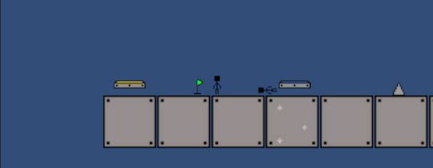
Description: An image of both teleporters and their sprites in-game. There can be multiple blue and yellow teleporters within a stage, but one specific yellow teleporter will always connect to one, specific blue teleporter.
Video: teleporter showcase 5-5-2026.mp4
With a few minor tweaks here and there needing to be made with the help of Liam, it was nearly up and running towards the end of this chunk of time of the project (Sprint 3).
Beginning Sprint 4, Ethan first adjusted the animations to the “Teleporter” prefab since they were not cycling properly. This was a quick fix that was done in a single school day. After that, we took a day to simply edit a previous progress report and divided up the work accordingly. While this was happening, Ethan made sure to stay productive by editing some previous sprites in terms of color. After that, Ethan decided to try and trim down on some goals that we knew we were not going to get to (such as the “Level Hub” idea). After that, he went back to planning out some theming and structuring for the levels (which probably should have been done earlier). This helped us better communicate our goals for the project. After that, Ethan spent some time editing and essentially finishing the entirety of “Level 1” in terms of game mechanics. Then, he moved onto getting a goal post up and running the form of a “Finish Flag” prefab.
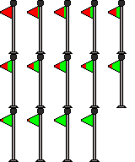
Description: A detailed sprite sheet illustrating the “Finish Flag” prop that is at the end of each level to help the player transition from level to level!
This would allow the player to then get a menu to continue on to another level. Ethan specifically made the sprite, animations, and code to fully add the entire “Finish Flag” prefab. This task took longer than anticipated, but with the help of Liam, some of the minor errors here and there could be easily corrected. Lastly, for Sprint 4, Ethan worked a tiny bit more on some sprites on the side.
For Sprint 5 and Sprint 6, a lot had to be done and completely polished. Both of these sprints were essentially intertwined (especially in terms of goals) so they are going to be attached for simplicity’s sake. To start, Ethan primarily focused on trying to help scale back the project some more since some things were becoming very clearly not feasible (such as seven levels, multiple paint tools, and fully detailed sprites). After that, Ethan spent a majority of the time trying to focus heavily on level creation (that being “Level 2” and eventually “Level 4”). Since we had significantly less time, these levels had to be done in a relatively short period of time (although what mainly made this easier for Ethan was having not only the experience with the long process in developing “Level 1,” but Maddie also started to work on level creation too so it was better for him to get someone else's eyes on the process). Although these sprints definitely contained the most work combined, not a whole lot can really be said about this since it was mainly just crunching out levels and thinking of good ideas. Some challenges that slowed down Ethan during this process were the paint tiles not yet being done on Liam’s end (and since he was the one who primarily started the paints, it was hard for Ethan and Maddie to really join in and make the process quicker). On top of this, when the paint tiles were actually finished for Ethan, sometimes they contained game breaking issues that made it impossible to work with them. Another huge hurdle for Ethan during this last level creation batch was understanding what to fix from the previous level creation chunk that “Level 1” had. Maddie working on “Level 3” definitely helped keep Ethan more organized when designing “Level 2,” but mainly “Level 4” and is what made that whole process faster. After all of that, Ethan got to work helping a little bit with setting up a “Community Level” that is essentially a “Level 5” made from stitched together pieces/ sections that our friends made.
Overall, all of his and everyone's progress led up to the “Final Report” assignment in which Ethan mainly helped write a lot to help Liam as he continued to work hard on patching everything up for the final submission of “Project Egress.” The biggest hurdle Ethan mainly came across was the beginning steps of setting up the virtual machine and software as well as the bugs and (what felt like) random errors when using the virtual machine. On top of the virtual machine being a little difficult to work with, they were also kind of slow (which slowed down the pacing of progress for him, especially since he was also trying to manage a Senior Capstone notes document online to allow us to review all archived notes we ever took for each other (pretty much starting with the first weeks of actually work on the project itself). Generally speaking, Ethan made a lot of progress with level creation, coding, and some sprite work throughout the entire Senior Capstone project.
Madeline jumped around a lot. She worked on scripts to get some main platformer mechanics done before jumping to animating, then UI before ending up helping with level creation.
At first she installed the virtual machine and all of the required technologies she messed around in Unity and did research on some general Unity engine. She also made the Trello page and kept it updated for the rest of the project. Unfortunately since she finished installing everything earlier than the other members she had an older version of Unity so she had to redownload Unity. She started working on player movement but then Liam decided to finish it at home that same weekend. After she fixed the issue of the player rotating all over the place after falling off the platform. She also at the same time decided to make all of the sprites for the character cycle through to give the character some form of movement but at that point it was just thought of as a placeholder character. She also had to waste time trying to uninstall the old Unity version because it didn’t automatically uninstall, causing the virtual machine to run way slower. This took a full day as Unity is not just slow with installing itself but uninstalling itself. She then went on to make death and respawn mechanics which were both very important to do. It took a lot of trial and error with messing around with the code, Unity tags and hitboxes. While messing around with player movement while she was talking with Liam about how painting should work she found a bug which allowed the player to wall jump. The original idea of how this happened was the feature she recommended to add which is coyote time. Coyote time is a mechanic in platforming games where it gives the player a few mercy frames after leaving the platform where they could jump in order to make the game more fair to the player (the name was inspired by Wile E. Coyote from Looney Tunes). Later they found out that the bug was actually caused by tiny invisible gaps between the tiles which Liam later fixed by editing the tile map. She went on to make sprites for the paint switching mechanic which she had trouble doing as there was no way to center anything so it took a while to get everything looking right.
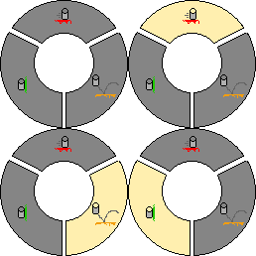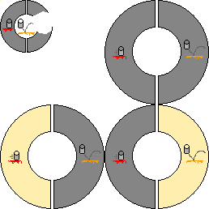
Description: Above are the paint switching wheels with the paint in them. Left features the one with all three paints while the right shows only two for earlier levels. In the top left corner on the image of the right one an earlier depiction of the wheels which were much smaller but due to that could not fit the paint bucket sprites for the paints.
She also around the same time worked on making the placeholder character animated as the group could just reuse the code and animator but throw new sprites inside in order to save time later on.

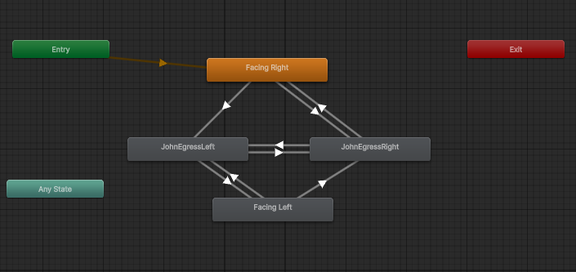
Description: Pictured above is the animation map within Unity showing how the player character is animated. The facing Left and right were going to be used when the full player character was created but that never happened.
She then taught Liam how to use the animator and code for it in order for him to make the fire spitter. She then coded the paint switch mechanic except the part where it actually switches the paint since painting wasn’t finished at the time. She then made a new branch for menus and UI which she did on her own for about a week. The menus and paint switching are gone over in this video: senior-cs-capstone-progress-report-4a.mp4.
During the final part of the development she changed gears from coding to making levels creating level 3. She then had the idea that due to levels being easy to make, what if the community made a level kind of like the stretch goal idea of having a Mario Maker esque level making system for people to create and share levels. So the final contribution she made was stitching together the Community Level (with a custom finish flag) and making sure all the levels are connected to the correct UI buttons.
Liam is the lead developer and the team’s IT support. Notably, nearly all bugs and errors that his teammates faced were solved and fixed by him. Additionally, most of the projects’ branch merges were done by him.
During sprints 1-2, Liam made simple and easy instructions to install a virtual machine that is ready for developing for the project. Additionally, he created the initial Unity project itself. For the initial movement scripting, Liam did most of the work on it. This included left-right and part of the jump functions. There is also the coyote time and jump buffering systems, which allow for late jumps when leaving the platform or early jumps before touching the platform, respectively.
Sprint 3 included the midterm. For the midterm, Liam created and compiled the first official game build, which was uploaded to the Releases page on the GitHub repository. Then, he created one of the planned traps, the Fire Spitter, which kills the player on intervals.
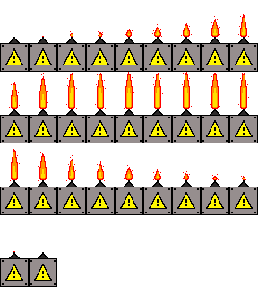
Description: A detailed sprite sheet illustrating the “Fire Spitter” prefab in its calmer, non-damaging state and its bigger, damaging state. It continues to turn on and off in a cycle with a small flame (that is non-damaging) that indicates when it will turn on soon to the player!
Video: fire spitter showcase 5-5-2026.mp4
For sprint 4, Liam focused on the painting effects and the pre-painted tiles. In this sprint, 2 out of the 3 pre-painted tiles were completed with their effects. These two tiles are the red and orange tiles. A demonstration of the tiles that used earlier code that can be found from this sprint can be seen here: senior-cs-capstone-progress-report-4b.mp4. He did help out Ethan in making the Finish Flag object, which allows for levels to be completed.
Now that crunch time has set in for sprint 5, Liam coded many planned major features. He finished all of the painting mechanics. This includes the third pre-painted tile, paint tool, paintball, and applying paints to tiles. The last paint effect, the green paint, rotates the player so that gravity is now in the direction of the collided tile that has the green paint. This effect, however, required an overhaul of the player movement system, which led to the creation of a custom gravity script that applies force based on the player’s rotation.

Demo Video - liam

senior-cs-capstone-final-report.mp4

Reflection and Closing Thoughts

Our project definitely had its ups and downs. One of the things that went well is that we were really lucky to discover the tilemap function in Unity. The tilemap essentially allowed you to build levels using your assets, kind of like how Mario Maker functions. This was also very helpful when having people make level segments for our Community Level as the people didn’t need any experience and were able to create the levels quickly. A coincidence that ended up working well was a lot of the sprites despite being placeholders worked really well when used together. Since we made all the sprites ourselves the sprites are somewhat more consistent and have a consistent style. The midterm playtest went extremely well and gave us valuable feedback that helped us fix bugs and know what people wanted from the game. As for things that did not go well, the virtual machines in general were terrible to use. The virtual machines not only took a long time to set up the first time they made us waste so much time. We were constantly running out of time due to the long loading times for every little action we do like editing one line of code or undoing something in unity would take up almost a minute not to mention how long it took to load us into the scenes to test our levels and mechanics. The virtual machines also had a tendency to blue screen which would cause us to waste even more time as sometimes when the virtual machine bluescreened we needed to get an entirely new virtual machine because Unity would stop working. We also would have preferred to have been in the same block. Being in the same block would have fixed some of the holes in communication and also would mean we wouldn’t have had to spend time where we could have coded in order to write to the people in the other block. We never were actually working on the same thing at all so we wouldn’t have ended up with all of us working on the same thing and losing time if we were together. We were also thinking way too big about what we had time to add. There is a lot we had to scrap like the paint tools, the finished player model, and menu sprites. There were also things that were just placeholders that we just had to leave in due to lack of time like the checkpoints, player, menus, and finish flags.
If we could go back we wouldn’t have picked a different project. Most of our problems came from conflicting views on how things should work leading to having to adjust code for our mechanics or adjust the levels. In the end however we ended up with a game that ended up working and having quite a decent amount of content including it being somewhat replayable due to the roughly 3 easter egg areas we added for exploration and also how certain areas can be solved in different ways making it kind of like a challenge to see how fast you can complete it. As for the technologies we used, VMWare was really annoying with the constant crashing as mentioned earlier. Unity was really simple to get used to but the loading times were really annoying especially as the file size increased, requiring more scripts, sprites, prefabs, scenes, etc. to load and C# was really easy to get used to partly because we all took a short course. The one thing with Unity is that it is overwhelming at first especially with learning how to do animation scripts and it is very overwhelming to try and make the UI elements at first. Both animations and UI we got used to though so in the end it wasn’t as bad as it was at the beginning. Piskel was really simple to use as there were a lot of self explanatory things one could do with the options it gives you. GitHub and Git were both surprisingly really simple to use and learning to resolve conflicts were just a little annoying and tedious rather than a hard task. Visual Studio Code is the same as always, so it was really nice to use, especially since we were all used to it already. To be honest we thought we would use Trello more but with us communicating through a document we never truly used Trello and would just update it every time a report came up.
The progress reports didn’t really seem that necessary for us and wasted our time. We understand the importance of it for the course in order to make sure we are on track, but since we were it took time away from the project. We do plan on continuing the project but we are going on hiatus probably after patching a few things with the release. We are already getting burnt out on the project and desperately want a break. We will probably start working on it (though less actively) throughout college potentially making a Steam release but we won’t make any promises. For next year we feel like you could possibly have them start working on this earlier. A lot of the Senior first half classes had finals that were projects (3 out of the 4 for most of the class). Where we are going with this is if it is possible to move up the final project for data science and get them working on setting up virtual machines/working on the Project Pitches it would save a lot of time and also make the end of semester less stressful. We also think that maybe allowing more people for more complex projects. For example keep websites at 1-3 but make it so games are 1-4 people maybe. This would allow for more mechanics, longer games, and more potential for less placeholder art to be in the end product. Another suggestion would be to give the “Detailed Summary” section of this document at the beginning of the semester. We feel like that if we worked on that instead it would make the ending less stressful of having to balance the final report, final slideshow, the video, and adding a few last minute changes all at the same time. It would also be showing you that the students are staying on top of the project (of course you could add another document going over the trello and next steps section to still see those). Next year, you should have the final report and video due the day after the game/website and presentation just like this year. It allowed us more time to polish the game the night before, whereas originally we would have needed to pull an all-nighter to finish all the parts of the final while still having the end result as polished. If possible push for an admin password so that future capstone groups don’t have to suffer with a virtual machine. I guarantee that the whole Capstone class will back you up that it should happen. The video portion definitely needs tweaking. It could be that we are misinterpreting how much detail we are actually expected to go into, but right now it feels like we need to somehow stretch what we showed we accomplished from a minute 40 to 6 minutes even though we already included code and showed off our mechanics. We understand that websites usually have a lot more to talk about, but for games most overview trailers which go over core mechanics, gameplay loops and what to expect usually only run somewhere between 2-4 minutes but we need to stretch that time to 6-10 minutes without going too much into the details of the coding and also without revealing everything about the short game.

